
Gokaraju Rangaraju Institute of Engineering and Technology
(Autonomous)
Department of Computer Science and Engineering
B.Tech., IV Year –Major Project Phase-I & II
Academic Year 2025-2026
Batch no. | E8
Domain | Machine Learning and Artificial Intelligence
Title | FixMyCity: Smart Civic Issue Reporting and Urban Decision Support System
Guide Name | Dr P Varaprasada Rao | Designation | Professor
Batch Details
  Roll no | Name | Mail id
  23241A05T4 | Bhuvanesh Neerukonda | bhuvaneshneerukonda10@gmail.com
  23241A05X2 | Pochampally Manikanta Reddy | manikantareddyp@gmail.com
  23241A05X3 | Puli Anirudh | anirudhpuli78@gmail.com
  23241A05X9 | Shaik Asharaf | asharafshaik420@gmail.com
Photos
  23241A05T4 | 23241A05X2 | 23241A05X3 | 23241A05X9
  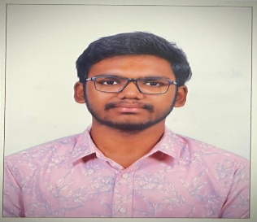 | 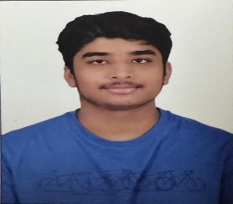 | 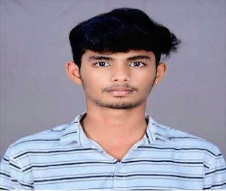 | 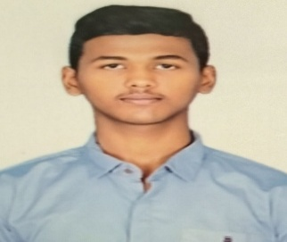
ABSTRACT
Rapid urbanization and complex civic infrastructure often make managing city issues challenging and limit effective resource allocation for municipal authorities. This project presents FixMyCity, an AI-powered smart civic reporting and urban decision support system that converts citizen-reported grievances into actionable urban intelligence using an integrated geospatial and machine learning pipeline. The system captures civic complaints such as potholes, water leakage, and streetlight failures through a web application or WhatsApp chatbot and converts them into categorised, geotagged, and prioritised records using an automated routing module. The generated reports are then processed using predictive analytics and machine learning (ML) techniques to analyse historical complaint trends and extract predictive insights that correspond to recurring civic problems and environmental degradation. These insights are matched with real-time environmental, weather, and geospatial datasets, which are then seamlessly synthesised using GIS-based visualisation and explainable AI techniques to produce actionable recommendations and interactive urban dashboards. The proposed system is transparent, data-driven, proactive, and suitable for real-time civic management without relying on inefficient traditional manual grievance tracking. It can be effectively deployed in municipal corporations, urban planning departments, environmental agencies, and smart city command centres to improve operational efficiency and accountability for both authorities and citizens. Furthermore, the project supports the United Nations Sustainable Development Goals (UN SDG 11: Sustainable Cities and Communities) by promoting intelligent, data-driven urban governance and UN SDG 6: Clean Water and Sanitation by enabling proactive groundwater management and sustainable conservation strategies.

Signature of the Guide
Dr P Varaprasada Rao
Professor

